

Master of Computer Application
Cybersecurity Specialization

MCA Cyber Security

3rd Semester

Subject Name:
Ethical Hacking & Penetration Testing

Assignment

Submitted To: Mr. Avinash Verma
Submitted By: Vishal Chudasama
Roll Number: E02
Enrollment Number: 25004401110069

Unit I - Foundations of Ethical Hacking

Question 1
Define ethical hacking. Explain the difference between White Hat, Black Hat, and Grey Hat hackers with suitable examples.

Answer
Ethical hacking is the authorized and legal practice of testing computer systems, networks, and applications to discover security weaknesses before criminals can exploit them. An ethical hacker works only with written permission, follows an agreed scope, avoids unnecessary damage or data exposure, documents the findings, and recommends fixes. The purpose is to improve confidentiality, integrity, and availability of information systems.
Hackers are commonly classified by their authorization, intent, and method of disclosure.
Type | Authorization and intent | Typical activity | Suitable example
White Hat | Has explicit permission and works to improve security. | Performs a controlled assessment, reports weaknesses, and supports remediation. | A company hires a security consultant to test its online banking portal before release.
Black Hat | Acts without permission for malicious or personal gain. | Steals data, installs malware, disrupts services, or demands ransom. | An attacker breaks into an e-commerce database and sells customer card data.
Grey Hat | May access or test a system without permission, but may not intend direct harm. | Finds a flaw independently and may disclose it, sometimes after accessing the system beyond authorization. | A researcher discovers an exposed website admin panel without approval and informs the owner; the access was still unauthorized.
In summary, the key distinction is authorization. White Hat hackers are authorized defenders; Black Hat hackers are unauthorized attackers; and Grey Hat hackers may have helpful intentions but operate without formal permission. Only White Hat activity is appropriate for an ethical hacking engagement.

Question 2
Explain the CIA Triad in cybersecurity. How do Confidentiality, Integrity, and Availability apply to an organization's security?

Answer
The CIA Triad is a foundational cybersecurity model used to guide security decisions. It consists of Confidentiality, Integrity, and Availability. An organization must protect all three because a system can be insecure even if only one of them fails.
Principle | Meaning | Organizational application | Example control
Confidentiality | Information is available only to authorized people and systems. | The organization restricts access to customer records, employee data, financial documents, and passwords. | Role-based access control, multi-factor authentication, encryption, and least-privilege permissions.
Integrity | Information remains accurate, complete, and protected from unauthorized change. | The organization ensures that business records, software, transactions, and reports cannot be altered improperly. | Input validation, hashes, digital signatures, audit logs, and change-control procedures.
Availability | Authorized users can access systems and data when needed. | The organization keeps essential services such as websites, email, payment systems, and backups operational. | Backups, redundancy, disaster-recovery plans, monitoring, patching, and DDoS protection.
For example, in an online banking system, confidentiality protects account details from unauthorized viewing; integrity ensures that transfers and balances are not changed fraudulently; and availability ensures that customers can access the service when required. Security controls should be balanced across all three principles.

Question 3
Explain the five phases of ethical hacking: Reconnaissance, Scanning and Enumeration, Gaining Access, Maintaining Access, and Clearing Tracks.

Answer
An ethical hacking engagement follows a structured process. The activities must be authorized in writing, limited to the agreed scope, and documented so that the organization can fix the identified weaknesses.
Phase | Purpose and typical activity | Ethical-hacking requirement
1. Reconnaissance | Collect information about the target before direct interaction. This may include public domain details, technologies, employee-facing information, and the attack surface. | Use only approved sources and the agreed target scope. Record the sources and information gathered.
2. Scanning and Enumeration | Identify reachable hosts, open ports, services, versions, users, shares, and other exposed resources. | Use approved scanning tools and safe scan settings. Avoid disruption and retain scan evidence for the report.
3. Gaining Access | Validate a weakness by obtaining controlled access to a system, application, or account in the lab or authorized target. | Use the least intrusive proof possible. Do not access unnecessary personal data or expand beyond the written scope.
4. Maintaining Access | Assess whether an attacker could retain access after initial compromise, such as through a temporary test account or a permitted persistence simulation. | Only simulate persistence when explicitly authorized. Use reversible methods and remove all test artifacts afterward.
5. Clearing Tracks | In malicious activity this means hiding evidence. In ethical hacking, it means safely cleaning up test files, accounts, sessions, and configuration changes. | Do not conceal actions from the organization. Preserve audit evidence for reporting, restore the environment, and confirm cleanup with the owner.
The final outcome of all five phases is a clear report: what was tested, which weaknesses were validated, the business impact, evidence of the findings, and prioritized remediation steps. Ethical hackers must keep the target owner informed throughout the engagement.

Question 4
Explain the concept of vulnerability assessment and penetration testing (VAPT). Differentiate between vulnerability assessment and penetration testing.

Answer
Vulnerability Assessment and Penetration Testing (VAPT) is a combined security-testing approach used to identify, evaluate, validate, and help remediate weaknesses in systems, networks, and web applications. A vulnerability assessment identifies and prioritizes possible weaknesses. Penetration testing goes further by safely attempting to validate whether selected weaknesses can be exploited and what impact they could have.
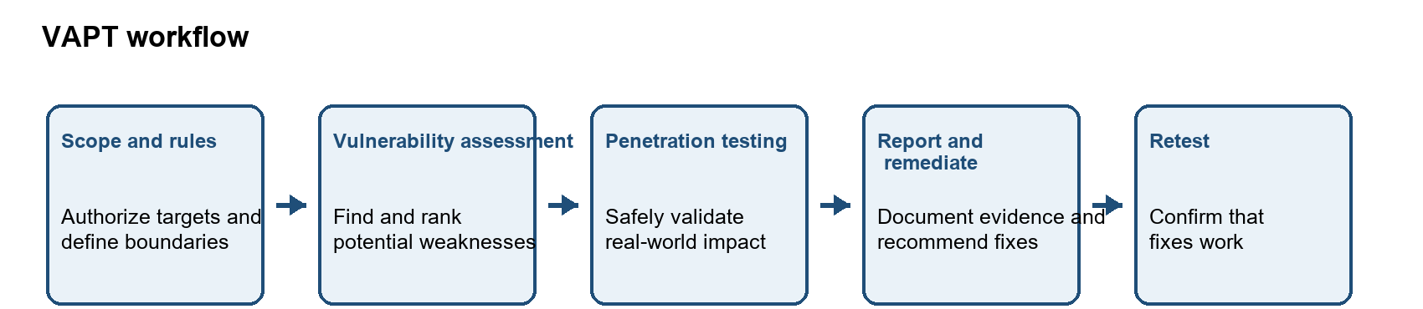
Figure 1. A typical authorized VAPT workflow.
Aspect | Vulnerability assessment | Penetration testing
Main purpose | Find and classify potential security weaknesses. | Safely validate selected weaknesses and determine their practical impact.
Depth | Broad coverage; often automated and repeated regularly. | Focused and deeper investigation of high-risk findings.
Typical tools | Vulnerability scanners, configuration checks, and asset inventories. | Controlled test tools, manual verification, proxy tools, and approved lab exploits.
Output | A list of possible vulnerabilities with severity and remediation guidance. | Evidence that a weakness was or was not exploitable, including impact and proof of concept.
Example | A scanner reports that a server may use outdated TLS settings. | A tester confirms in scope that the weak settings permit an insecure connection and documents the risk.
In practice, an organization should use both activities. Regular vulnerability assessments provide wide and continuous visibility, while periodic penetration tests demonstrate whether important weaknesses can lead to meaningful business impact. All testing must be authorized and performed within defined rules of engagement.

Unit II – Reconnaissance, Scanning & Enumeration

Question 5
What is passive reconnaissance? Explain how Google Dorking can be used to identify publicly available information about a target.

Answer
Passive reconnaissance is the collection of information about an organization from sources that are already publicly available, without directly probing or interacting with its systems. It helps an authorized security tester understand the visible attack surface while minimizing impact on the target. Typical sources include public websites, search engines, DNS records, WHOIS data, social-media posts, job advertisements, and documents published online.
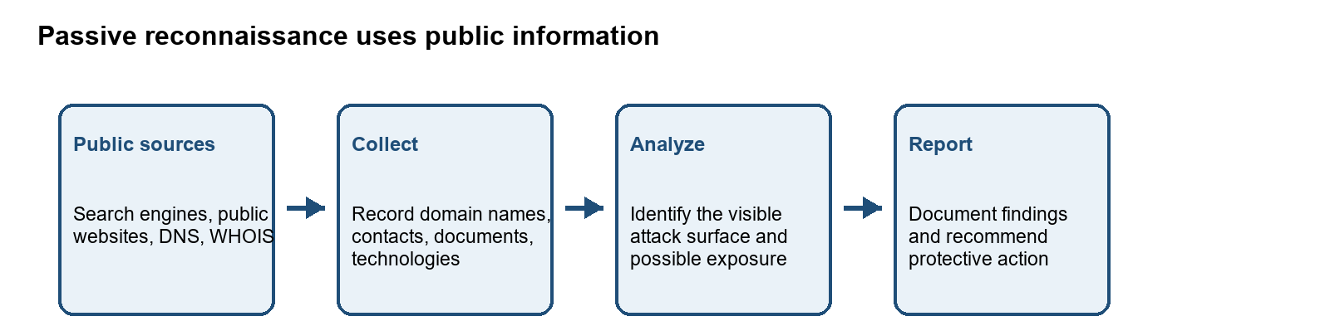
Figure 2. Passive reconnaissance workflow in an authorized assessment.
Google Dorking, also called Google hacking, uses advanced Google search operators to narrow results and locate information that has been indexed publicly. It does not grant access to private systems; it only reveals content that search engines can already find. In an authorized assessment, it can help identify exposed documents, public login pages, subdomains, technology references, and accidental information disclosure.
Search operator | Safe example | Possible authorized observation
site: | site:example.org | Lists indexed pages from a specific approved domain.
filetype: | site:example.org filetype:pdf | Finds publicly indexed PDF documents on the approved domain.
intitle: | site:example.org intitle:login | May locate publicly visible pages with a selected word in the title.
inurl: | site:example.org inurl:contact | May identify public URLs that contain a selected term.
Example: an authorized tester might search an approved organization domain for PDF files to check whether public documents unintentionally reveal software versions, internal email addresses, or outdated contact information. Any sensitive discovery should be documented responsibly and reported to the organization; the tester must not use it to access systems or accounts.

Question 6
Explain WHOIS, nslookup, and dig. What type of information can be obtained using each tool?

Answer
WHOIS, nslookup, and dig are information-gathering tools commonly used when examining domain registration and DNS. WHOIS queries registration data, while nslookup and dig query the Domain Name System (DNS), which maps domain names to records such as IP addresses and mail servers. The information returned depends on the domain registry, DNS configuration, and privacy protections in place.
Tool | What it queries | Information commonly returned | Example use
WHOIS | Domain registration databases and registrar/registry services. | Registrar, registration and expiry dates, domain status, name servers, and registrant details when those details are not redacted. | Check which name servers are associated with a domain and when its registration expires.
nslookup | DNS records using a DNS resolver. | A/AAAA address records, MX mail servers, NS name servers, and sometimes TXT or other records, depending on query and implementation. | Look up the IP address or mail server for a domain from a command prompt or terminal.
dig | DNS records using a DNS resolver, with detailed response information. | Requested record data, DNS response sections, TTL values, flags, and query timing; supports explicit record types such as A, MX, NS, and TXT. | Inspect a specific DNS record and the answer/authority sections returned by a resolver.
Example commands for a domain you are authorized to examine are shown below. Replace example.org with the domain in scope. WHOIS availability and output format can vary by operating system and registry.
whois example.org
nslookup example.org
nslookup -type=MX example.org
dig example.org A
dig example.org MX
For example, an MX lookup can show which mail servers receive email for a domain, while an A lookup returns an IPv4 address when one is published. These results describe public configuration; they do not prove that a host is vulnerable or that a service is reachable. Record the query and observation accurately, and perform any further testing only on authorized targets.

Question 7
Perform passive reconnaissance on an authorized domain using theHarvester, WHOIS, nslookup, and dig. Document the domains, subdomains, IP addresses, DNS records, mail servers, and other relevant information identified.

Answer
Passive reconnaissance collects information from public sources and DNS without trying to exploit or gain access to the target. This exercise was performed on vulnweb.com, a public test domain intended for security-tool practice, from a Kali Linux virtual machine in VMware Workstation. The lab commands were run on 10 October 2026. The VM used the NAT resolver at 192.168.222.2 for DNS queries. The certificate sources used by theHarvester receive the domain name as a query.

Procedure
- The terminal was opened in the Kali Linux VM, and a working folder was created (mkdir ~/q7 && cd ~/q7).
- theHarvester 4.10.1 was run with the passive certificate sources crtsh and certspotter. Its output was saved as q7_recon (XML and JSON).
- WHOIS, nslookup and dig were run one at a time, and the output was saved as screenshots.
- The DNS results from nslookup and dig were compared.

Commands used
theHarvester -d vulnweb.com -b crtsh,certspotter -f q7_recon
whois vulnweb.com
nslookup vulnweb.com
nslookup -type=MX vulnweb.com
dig vulnweb.com A
dig vulnweb.com MX
dig vulnweb.com NS
dig vulnweb.com TXT
theHarvester queries the selected public certificate sources and collects any domains, subdomains, IP addresses and e-mail addresses they return. WHOIS shows registration data such as the registrar, dates, status and name servers. nslookup and dig query DNS. A and AAAA records give IPv4 and IPv6 addresses, MX records name the mail servers, NS records name the authoritative name servers, and TXT records hold text such as domain-verification and e-mail policy data.

Results to record
Information requested | Your observed result | Source / command
Domain | vulnweb.com | All commands
Subdomains / hostnames | No result returned. theHarvester reported no hosts, IPs, e-mails or people from crtsh and certspotter. | theHarvester
IP addresses (A / AAAA) | A: 44.228.249.3.  AAAA: 64:ff9b::2ce4:f903 | nslookup;  dig A
DNS records (NS / TXT / other) | NS: ns-136.awsdns-17.com, ns-557.awsdns-05.net, ns-1450.awsdns-53.org, ns-1588.awsdns-06.co.uk. TXT: a Google site-verification record and an SPF record (v=spf1 ~all). | dig NS; dig TXT
Mail servers (MX) | Registrar: Gandi SAS (IANA ID 81). Created: 2010-06-14. Updated: 2026-06-01. Expires: 2027-06-14. Status: clientTransferProhibited. DNSSEC: unsigned. Name servers: the same four as in the NS row. | nslookup -type=MX; dig MX
WHOIS details (as publicly available) | Complete after the authorized run | whois

Screenshot evidence
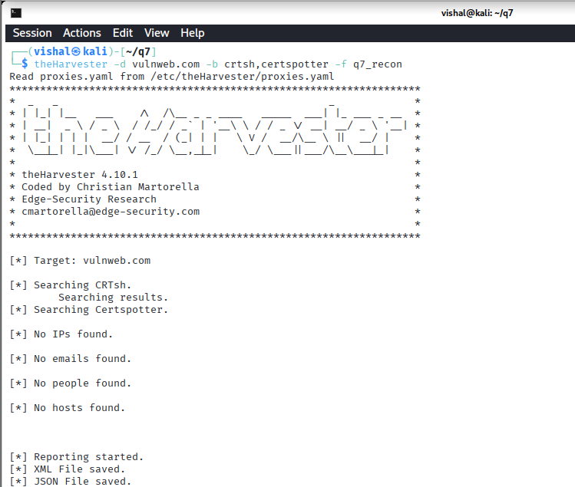
Figure 3: theHarvester passive reconnaissance output for vulnweb.com using crtsh and certspotter.

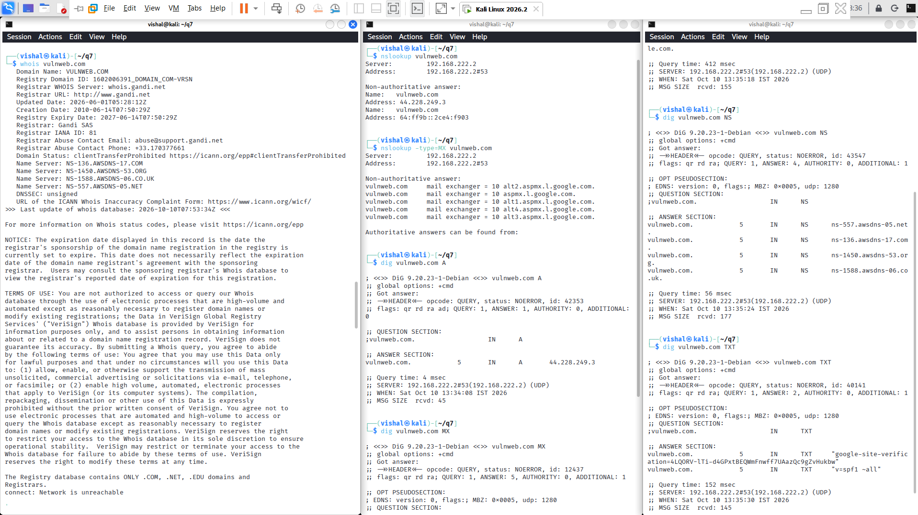Figure 4: WHOIS, nslookup and dig output for vulnweb.com.

Conclusion
Passive reconnaissance of vulnweb.com showed its A and AAAA records, its four name servers, five Google mail servers, its TXT records and its registration details. It did not need any direct interaction with the target's own services. The exercise also shows why DNS and WHOIS data should be reviewed by defenders. Details such as mail providers, DNS hosting and e-mail policy are public and can help an attacker, so organizations should review what they expose.

Question 8
What is active reconnaissance? Explain how Nmap can be used to identify open ports, running services, service versions, and operating-system information.

Answer
Active reconnaissance gathers information by sending probes or requests directly to a target system. Unlike passive reconnaissance, it interacts with the target and may appear in its logs or trigger monitoring alerts. Network Mapper (Nmap) is a network discovery and security auditing tool that can test which ports respond and help identify the services available on an authorized host. It should be used only against systems included in written authorization or an isolated lab.
Nmap option / output | What it does | What the result tells the tester
Default scan / port and state | Checks commonly used TCP ports and classifies their response. | Open means a service is accepting connections; closed means reachable but no application is listening; filtered means a firewall or other filter prevents Nmap from deciding.
-sV | Probes discovered ports to identify the service protocol, application, and when possible its version. | Helps distinguish what is actually listening from a guess based only on the port number. A version may not always be identified.
-O | Uses TCP/IP stack fingerprinting to estimate the target operating system and device type. | Provides a best-match OS guess. Results can be uncertain, especially when the target or network filters responses.
PORT / SERVICE / VERSION columns | Summarize the port number and transport, observed state, likely service, and any detected product/version. | Provides a concise inventory of the network-facing services observed during the scan.
Example command for a deliberately vulnerable machine on an isolated lab network (replace the address with the actual IP of your authorized Metasploitable or other lab target):
nmap -sV -O 192.168.56.101
This command scans Nmap's commonly used TCP ports, attempts service/version identification, and requests OS detection. If it reports, for example, an open TCP port with a service name and version, that means the service responded to Nmap's probes; it does not by itself prove that the service is vulnerable. An OS result is an estimate, and Nmap may report that it could not determine the OS. Actual findings depend on the lab host and network, so record your own output if you perform the scan.
References: Nmap Reference Guide, Port Scanning Basics; Service and Version Detection; OS Detection. https://nmap.org/book/man-port-scanning-basics.html
https://nmap.org/book/man-version-detection.html
https://nmap.org/book/man-os-detection.html

Question 9
Perform an Nmap scan against an authorized lab target. Identify the open ports, services, service versions, and OS information. Present your findings in a structured table.

Answer
This practical scan was performed against Metasploitable, an intentionally vulnerable virtual machine, at 192.168.184.130. The target ran in VMware on the same NAT network as the Kali Linux testing VM, and no public or unrelated address was scanned. Nmap 7.99 was used on 10 October 2026.
Procedure
- The Metasploitable VM was started, and its IP address (192.168.184.130) was found from its console.
- In the Kali Linux VM, connectivity to the target was confirmed with ping -c 4 192.168.184.130. All four packets were received with 0% packet loss.
- Run below command with sudo, and the output was saved to a text file.
Command used
sudo nmap -sV -O -oN q9_nmap_result.txt 192.168.184.130
-sV probes discovered ports to identify services and versions; -O requests operating-system fingerprinting; -oN saves a readable report. The default scan checks Nmap's 1000 most commonly used TCP ports.

Observed scan results
The host was up with a latency of 0.0018 s. Of the 1000 TCP ports scanned, 22 were open and 978 were filtered (no response). The scan took 181.06 seconds. The table lists the key services. The complete list of ports is shown in the screenshot below.
Port / protocol | State | Service | Version / product | Observation
21/tcp | open | ftp | vsftpd 2.3.4 | File transfer service; FTP sends data unencrypted.
22/tcp | open | ssh | OpenSSH 4.7p1 Debian 8ubuntu1 (protocol 2.0) | Encrypted remote login; an older release.
23/tcp | open | telnet | Linux telnetd | Remote login without encryption.
25/tcp | open | smtp | Postfix smtpd | Mail transfer service.
80/tcp  8180/tcp | open | http | Apache httpd 2.2.8 ((Ubuntu) DAV/2) | Web server; a web-application test surface.
111/tcp | open | rpcbind | 2 (RPC #100000) | RPC port mapper for related network services.
139/tcp  445/tcp | open | netbios-ssn | Samba smbd 3.X - 4.X (workgroup: WORKGROUP) | Windows file-sharing (NetBIOS) service. SMB file-sharing service.
Target IP: 192.168.184.130 (Metasploitable VM, VMware NAT network)
OS information: OS detection was inconclusive. Nmap warned that the results "may be unreliable" because it could not find at least one open and one closed port, since all other ports were filtered. It reported "No exact OS matches" and gave only guesses: Actiontec embedded (91%), Linux 2.4.X or 3.X (91%), and Microsoft Windows XP, 7 or 2012 (87%). The service information is more useful: Nmap reported hosts metasploitable.localdomain and irc.Metasploitable.LAN, with operating systems "Unix, Linux", so the target is most likely a Linux system.

Screenshot evidence
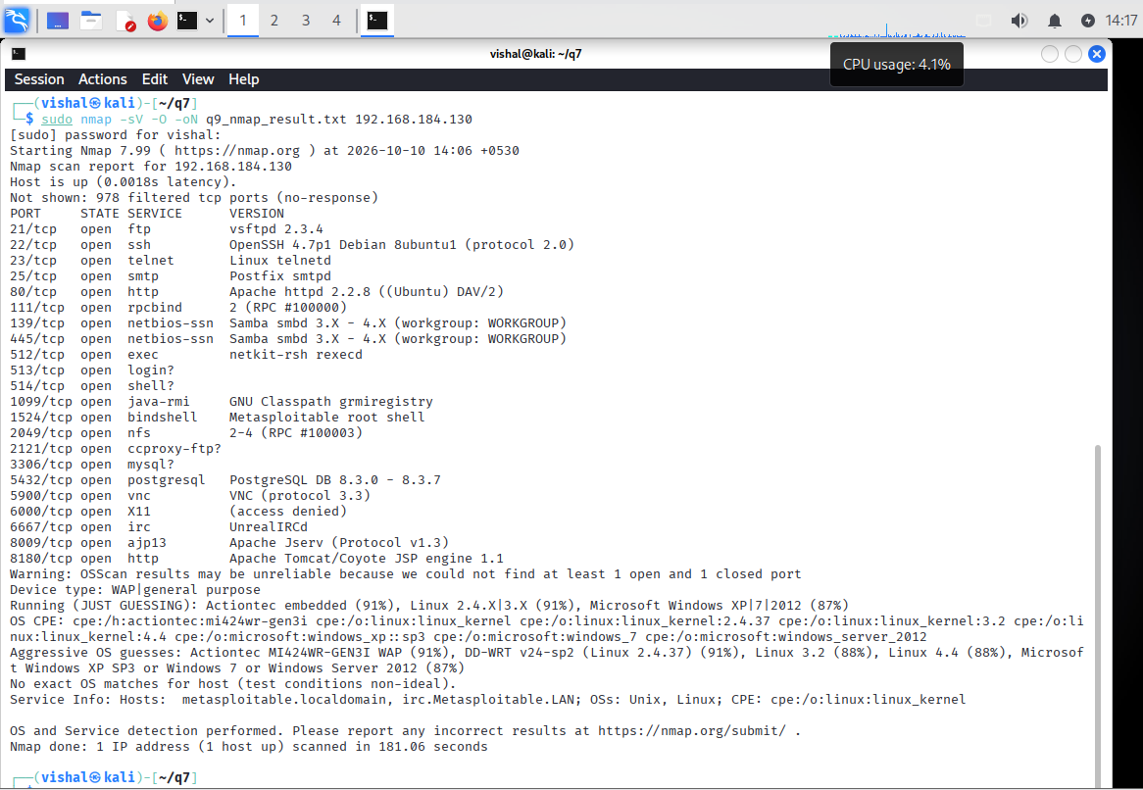
Figure 5: Nmap -sV -O scan of the Metasploitable target (192.168.184.130), showing open ports, service versions and OS detection output.

Conclusion
The scan identified 22 open TCP ports on the lab target, with services and versions for most of them, and the OS could not be confirmed. It also shows why unnecessary services should be turned off and why systems should be patched and filtered by a firewall. Scanning should always stay within the authorized lab scope.

Unit III – System Exploitation & Post-Exploitation

Question 10
Explain the Metasploit Framework architecture. Describe the purpose of exploits, payloads, encoders, auxiliary modules, and post-exploitation modules.

Answer
The Metasploit Framework is an extensible penetration-testing platform. Its console and framework libraries let an authorized tester select modules, configure their options, run controlled checks, and manage results or sessions. Modules are distinct components that perform particular tasks. A typical authorized validation flow pairs an exploit module with a compatible payload, while auxiliary modules can gather or verify information and post modules can perform approved checks after a test session is established.
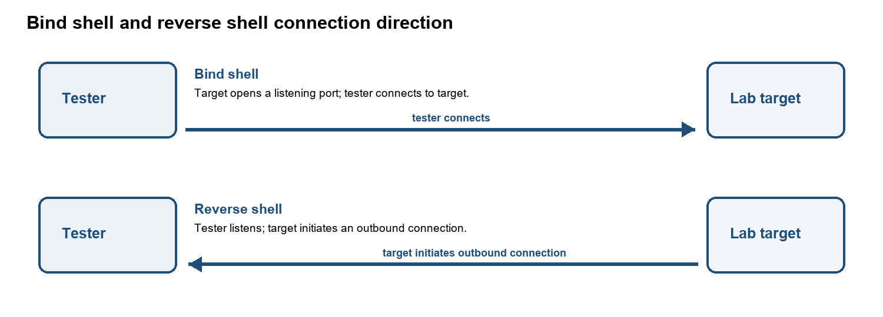
Figure 6: Simplified Metasploit module architecture and test flow.
Component | Purpose | Role in an authorized assessment
Exploit module | Implements a method for testing or taking advantage of a particular vulnerability or misconfiguration. | Used only against an in-scope lab target to validate a known weakness, with approval and safeguards.
Payload | Specifies the action or code that runs if an exploit succeeds, such as opening a controlled session. | Chosen to match the target platform and test objective. Payload selection is separate from the exploit itself.
Encoder | Transforms payload bytes to meet constraints such as avoiding characters that would break delivery or fit a required format. | May help with technical compatibility. Encoding does not guarantee antivirus or security-control evasion.
Auxiliary module | Performs supporting tasks such as information gathering, service checks, or other operations that do not use an exploit payload. | Can help assess or verify a service without establishing a shell/session.
Post-exploitation module | Runs approved checks through an established session to gather system information or validate security impact. | Used only within the authorized objective; minimize access to sensitive data and clean up test artifacts.
Metasploit modules do not make a test authorized by themselves. The tester must obtain permission, follow the agreed scope, use a lab or approved target, and document the selected tools, actions, results, and cleanup.
Reference: Rapid7 Metasploit Documentation, Getting Started - Metasploit Architecture. https://docs.rapid7.com/metasploit/getting-started/

Question 11
Explain the difference between bind shell and reverse shell. Discuss situations in which each type of shell may be used in a controlled penetration-testing environment.

Answer
A shell is a command-line interface that can provide interactive access to a computer. In a controlled penetration test, bind and reverse shells describe which side initiates the network connection. They are assessed only in a lab or on an explicitly authorized target, because a shell can allow commands to run with the permissions of the affected process.
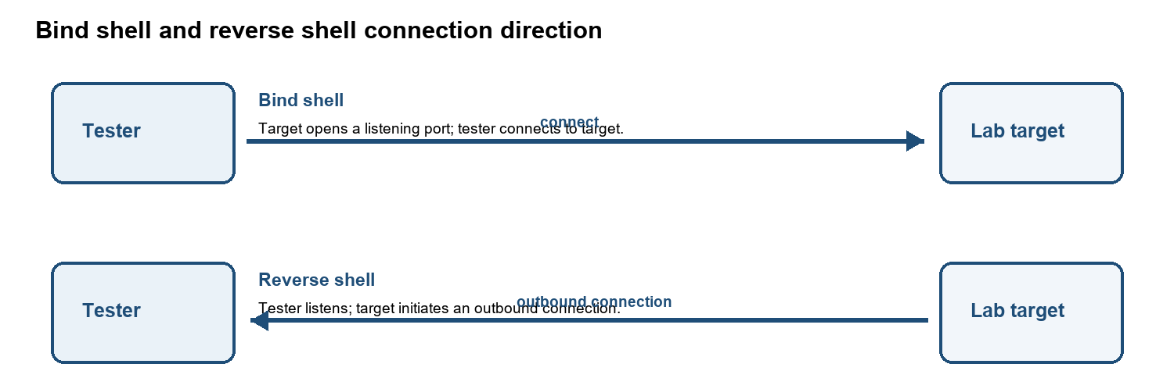
Figure 7: The connection initiator differs between bind and reverse shells.
Bind shell
In a bind shell, the target machine opens a listening port and waits for the tester to connect to it. The tester initiates the connection, so the traffic flows inbound to the target. In a controlled lab, this approach makes sense when the test network allows inbound connections to the target and the listening service can be observed and controlled safely. Its main weakness is that host and network firewalls usually block unsolicited inbound connections. The open port can also be seen, or even reached, by other machines on the network, so it should be restricted to the tester's address and closed as soon as the test ends.
Reverse shell
In a reverse shell, the roles are swapped. The tester's machine listens, and the target initiates an outbound connection back to it. In an isolated lab, this is the usual choice when inbound connections to the target are blocked but an outbound route is permitted. Outbound traffic is often filtered less strictly than inbound traffic, which is why this method is more common. It still has limits: egress filtering can block the callback, the listener's address and the routing must be configured correctly, and security monitoring may flag the unusual outbound connection. That alert is useful for the defenders, because it shows what their controls can detect.
Choosing between them
The deciding factor is the direction in which the network allows connections. If inbound access to the target is permitted, a bind shell is possible. If only outbound traffic is allowed, a reverse shell is the practical option. In both cases, the tester should record which type was used, why it was chosen, and the evidence it produced.
Both types create an interactive session and therefore carry risk. A tester should agree on the permitted payload, callback direction, ports, time window, and cleanup plan before testing. For many assessments, a non-interactive proof or scanner result is safer than opening a shell.

Question 12
What is privilege escalation? Explain the difference between vertical and horizontal privilege escalation with suitable examples.

Answer
Privilege escalation occurs when a user or process obtains permissions beyond those properly assigned to it. It can result from software flaws, excessive permissions, weak access-control checks, exposed credentials, or incorrect system configuration.
Vertical privilege escalation:
In vertical privilege escalation, a user or process moves up to a higher privilege level or role than it was given. For example, a standard employee account opens an administrator-only settings page or runs an administrative action. The impact is serious because the attacker may change system configuration, reach much more data, or take control of other accounts.
Horizontal privilege escalation:
In horizontal privilege escalation, a user stays at the same privilege level but reaches the data or actions of another user. For example, a customer changes an account identifier in a request and sees another customer's order history. No administrator rights are gained, but the records of other users can still be exposed or changed, which breaks confidentiality and integrity.
Key difference
Vertical escalation changes how much power the user has (user to admin). Horizontal escalation changes whose data the user can reach, while the power level stays the same. Both come from missing or weak authorization checks.
Applications should enforce authorization on the server for every sensitive action and data object. They should deny access by default, verify ownership or role for each request, apply least privilege, and log denied access attempts. Changing a button or URL in the browser should never be enough to grant permission.

Question 13
Explain persistence in post-exploitation. Discuss common persistence concepts and why persistence should be detected and removed during incident response.

Answer
Persistence is an attacker's ability to regain access after an initial compromise, including after a user logs out or a system restarts. During an authorized assessment, persistence is simulated only when the rules of engagement explicitly allow it. Incident responders treat unexpected persistence as evidence that an intruder may still control an account or system.
Persistence concept | What defenders may check | Response consideration
Unrecognized accounts, keys, or tokens | Review local and cloud account changes, SSH authorized keys, API tokens, and authentication logs. | Preserve evidence, disable unauthorized identities, rotate secrets, and revoke active sessions or tokens.
Startup entries, scheduled tasks, or services | Compare autorun items, scheduled jobs, services, and system configuration against a known-good baseline. | Determine origin and scope before removal; remove unauthorized entries and close the weakness used to add them.
Web shells or modified application files | Check web roots, file integrity alerts, unexpected scripts, deployment history, and server logs. | Isolate the host as needed, preserve a forensic copy, remove malicious files, and restore verified code.
Cloud or identity-provider persistence | Audit new app registrations, federated credentials, role grants, mailbox rules, and unfamiliar login sessions. | Revoke suspicious grants and sessions, rotate credentials, and review linked systems for further access.
Persistence must be investigated because simply deleting the first visible file may leave another access route in place. Responders should contain the incident, preserve logs and evidence, identify all affected accounts and systems, remove unauthorized access mechanisms, remediate the original entry point, and verify the environment before returning it to service. Reimaging may be appropriate when system integrity cannot be trusted.

IV – Web Application Penetration Testing

Question 14
Explain the OWASP Top 10. Describe any five vulnerabilities from the OWASP Top 10 and provide a brief example of each.

Answer
The OWASP Top 10 is an awareness document that summarizes major categories of web application security risk. OWASP's current released edition is the 2025 list. It supports security education and prioritization; it is not a complete checklist or a substitute for testing a particular application.
The OWASP Top 10:2025 lists the following ten categories:
- A01 – Broken Access Control
- A02 – Security Misconfiguration
- A03 – Software Supply Chain Failures
- A04 – Cryptographic Failures
- A05 – Injection
- A06 – Insecure Design
- A07 – Authentication Failures
- A08 – Software or Data Integrity Failures
- A09 – Security Logging and Alerting Failures
- A10 – Mishandling of Exceptional Conditions

Five categories with examples
Category | Explanation | Brief example
A01 Broken Access Control | The application fails to enforce what a logged-in user is allowed to view or change. | A customer edits an order ID in a URL and sees another customer's order.
A02 Security Misconfiguration | A system or application uses unsafe settings, unnecessary features, or default credentials. | A production server exposes a sample admin page with its default password still enabled.
A03 Software Supply Chain Failures | A weakness or compromise in dependencies, build tools, update channels, or software distribution affects the application. | A project includes an unmaintained vulnerable library and does not inventory or update it.
A05 Injection | Untrusted input is interpreted as part of a command or query instead of as data. | An application concatenates a search field into SQL, allowing crafted input to change the query.
A07 Authentication Failures | Weak identity verification or session handling lets an attacker impersonate a user. | A login has no effective rate limit, allowing repeated guesses against a weak password.
These examples are illustrative. The correct category for a real finding depends on the root cause and the OWASP edition being used. A single application issue can relate to more than one risk category.
Reference: OWASP Top 10:2025, official list and category descriptions. https://top10.owasp.org/2025/

Question 15
Using DVWA, demonstrate a Brute Force vulnerability using Hydra in an authorized lab environment. Explain the vulnerability, observations, and security controls that can prevent brute-force attacks.

Answer
A brute-force weakness exists when an application allows repeated login attempts without effective controls, making it easier to guess a password. This exercise was performed against the DVWA Brute Force page bundled with Metasploitable, at 192.168.184.130, with DVWA Security set to Low, from a Kali Linux VM on the same isolated lab network.
Procedure
- DVWA was opened at http://192.168.184.130/dvwa/vulnerabilities/brute/ and a normal login attempt was tested by hand with a wrong password. The page returned "Username and/or password incorrect.", confirming the exact failure text.
- The browser's Network tab was used to capture the request: a GET request to /dvwa/vulnerabilities/brute/ with username, password and Login as URL parameters, and a Cookie header containing security=low and PHPSESSID.
- A small test-only password list was created locally: 123456, username, vishal08, admin123, password
- Hydra was run with one thread and a short wait, targeting only the lab IP:
hydra -l vishal -P q15-small.txt 192.168.184.130 http-get-form \ "/dvwa/vulnerabilities/brute/?username=^USER^&password=^PASS^&Login=Login#:F=Username and/or password incorrect.:H=Cookie\: security=low; PHPSESSID=d61f550ef3c7b0b00794770ce87f44d3" -t 1 -W 2

Observed result
Hydra reported a match on the very first password in the list:
[80][http-get-form] host: 192.168.184.130 login: vishal password: 123456
1 of 1 target successfully completed, 1 valid password found
This result is a false positive. 123456 is not the account's real password (vishal08). The cause was the session cookie: the PHPSESSID used in the Hydra command belonged to a browser session that was already authenticated in DVWA. Because a valid session was attached to every request, the Brute Force page treated each attempt as already logged in and never returned the failure text, regardless of which password Hydra sent. Hydra matched on the first password tried simply because the page never showed the failure string.
Why this is a useful finding
This shows that an authenticated session cookie can bypass the brute-force check entirely, rather than relying on the submitted username and password, which is itself worth noting as a testing observation: a tester must ensure the session used for this kind of request is in the expected (logged-out) state, or the test will not exercise the actual login check. In a real assessment, this would also be reported as a secondary issue: the server is not re-validating credentials against an active session, which could be relevant to session-handling and access-control review.
Target: 192.168.184.130 (DVWA on Metasploitable, VMware NAT lab network)
Tool and command: Hydra; the http-get-form command above

Evidence screenshots:
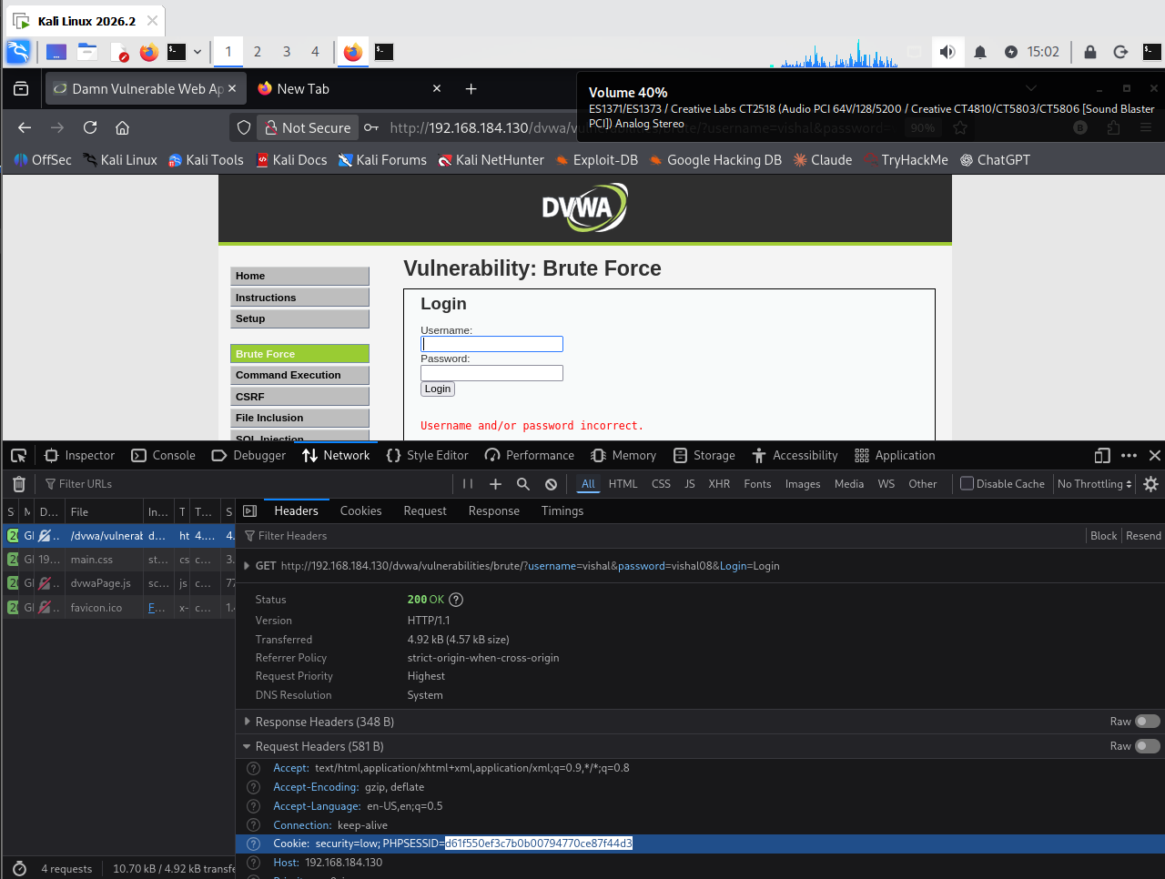Figure 8: DVWA Brute Force page and browser DevTools showing the captured request, cookie, and the real "Username and/or password incorrect." failure text.
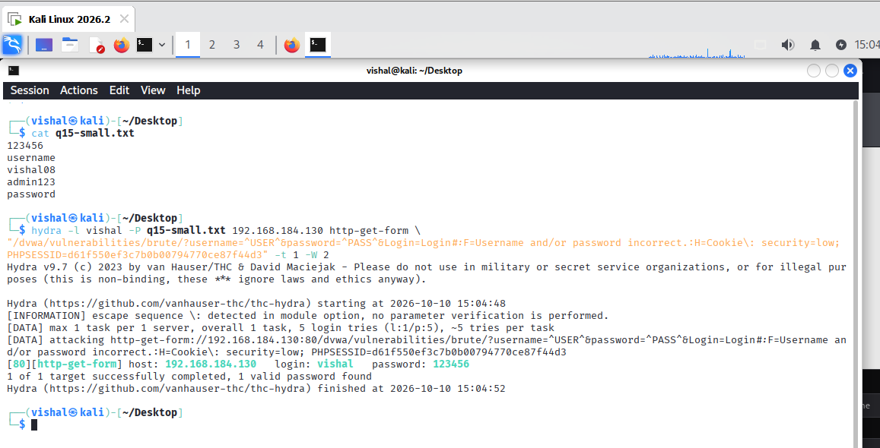
Figure 9: Hydra command and result showing the match on 123456.

Controls
Brute-force attacks can be prevented with rate limiting, progressive delays, temporary lockout or risk-based challenges, multi-factor authentication, password screening against known-compromised passwords, secure password hashing, monitoring and alerting for repeated failures, and secure account-recovery design. Session handling also matters: an application should re-validate credentials on each login attempt regardless of any existing session state, and controls should avoid creating a simple denial-of-service path through permanent account lockout.

Question 16
Using DVWA and Burp Suite, demonstrate how an intercepted HTTP request can be analyzed and modified. Explain the purpose of Proxy, Repeater, and Intruder in Burp Suite.

Answer
Burp Suite is a web security testing tool used to intercept, analyze, and modify HTTP requests and responses between a browser and a web application.
This practical was performed using DVWA on Metasploitable (192.168.184.130) through Kali Linux in VMware.
Procedure
- Opened Burp Suite and configured Firefox to use the proxy at 127.0.0.1:8080.
- Enabled interception in Proxy and submitted 127.0.0.1 on the DVWA Command Execution page.
- Inspected the intercepted HTTP POST request, including its headers, cookies, and form parameters.
- Sent the request to Repeater and changed the IP parameter from 127.0.0.1 to 127.0.0.2.
- Clicked Send and observed the response. The server returned HTTP 200 OK, and the DVWA page displayed successful ping results for 127.0.0.2.

Purpose of Burp Suite Tools
Burp tool | Purpose
Proxy
  Intercepts and displays HTTP requests and responses for inspection.
Repeater | Allows requests to be modified and resent to compare responses.
Intruder
  Automates requests using selected payloads to test parameters with different values.

Screenshot Evidence
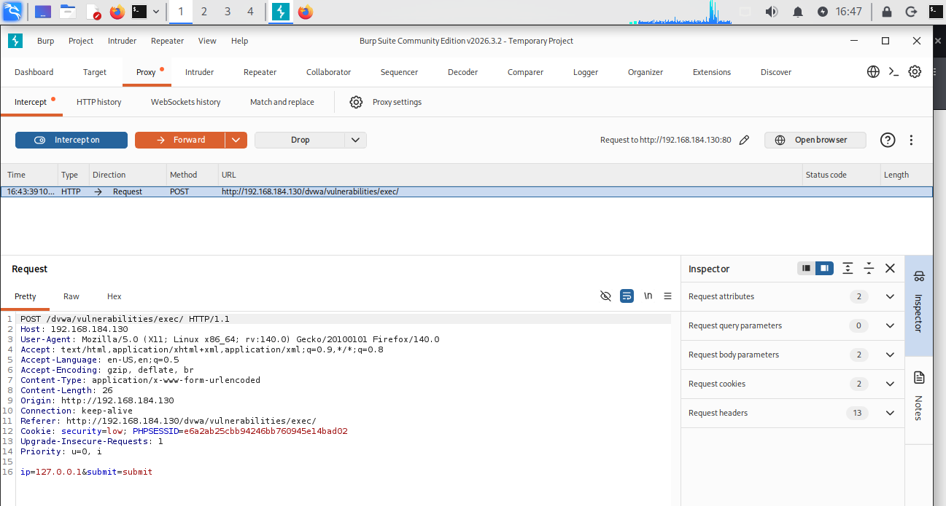
Figure 10: Intercepting HTTP Request Using Burp Proxy

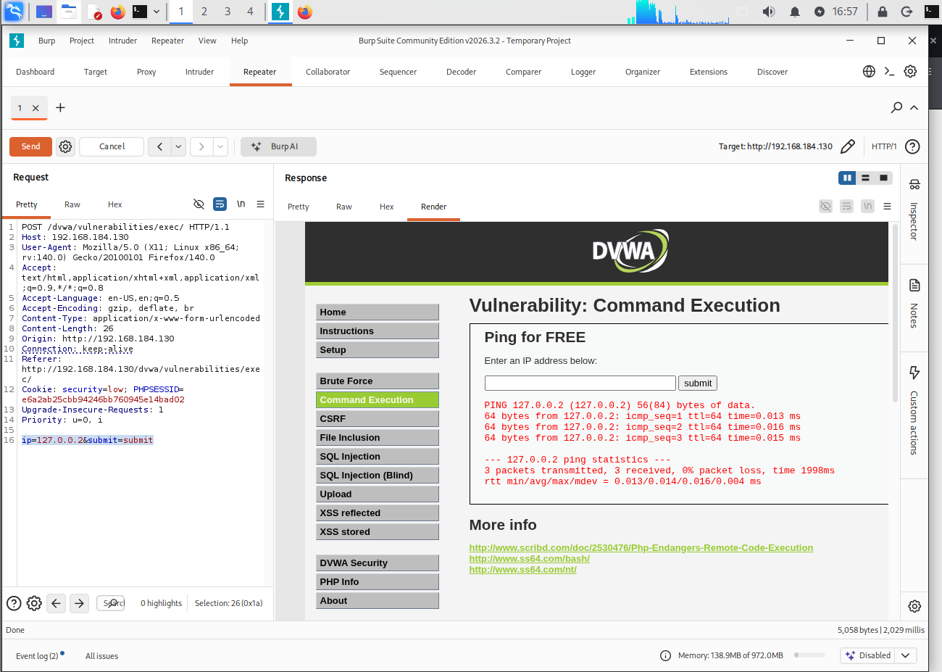
Figure 11: Modifying and Resending Request Using Repeater

Conclusion
Burp Suite was used to intercept an HTTP request from DVWA, inspect its parameters, modify the IP value, and resend the request using Repeater. The response showed how changing a request parameter can affect application behavior. Proxy, Repeater, and Intruder are useful tools for different stages of web application security testing.

Question 17
Using DVWA, investigate SQL Injection. Explain how user input can affect a database query, identify the vulnerability, and discuss appropriate mitigation techniques such as parameterized queries.

Answer
SQL Injection (SQLi) is a web application vulnerability where an attacker can manipulate database queries by entering malicious SQL code into an input field. This may allow access to data that should not normally be displayed.
This practical was performed using DVWA on Metasploitable (192.168.184.130) through Kali Linux in VMware. The DVWA security level was set to Low.

Lab procedure to complete later
- Opened DVWA in Firefox and selected the SQL Injection page.
- Entered the normal User ID 1 and clicked Submit. The application returned the admin user's details.
- Entered the SQL Injection input: 1' OR '1'='1' #
- Clicked Submit again. This time, DVWA displayed five user records instead of one.
- Opened View Source and observed that the PHP code directly inserts user input into the SQL query using mysql_query().

Observed Results
Input | Result
1 | Displayed only the admin record
1' OR '1'='1' # | Displayed five user records
The returned users were admin, Gordon Brown, Hack Me, Pablo Picasso, and Bob Smith.
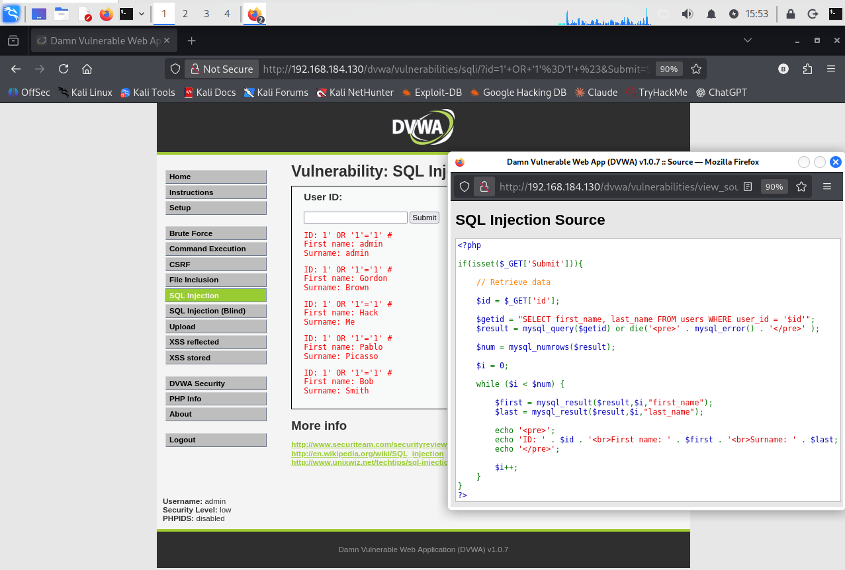
Screenshot Evidence:
Figure 12: SQL Injection demonstration in DVWA showing five user records and vulnerable PHP source code.

Vulnerability and Mitigation
The vulnerability occurs because DVWA directly adds user input to the SQL query without proper protection. The condition '1'='1' is always true, which causes the query to return multiple records.
To prevent SQL Injection:
- Use parameterized queries (prepared statements) instead of directly adding user input to SQL.
- Validate user input on the server side.
- Give database users only the required permissions.
- Avoid displaying detailed database errors to users.

Conclusion
SQL Injection was successfully demonstrated in DVWA. The normal input returned one record, while the injected input returned five records. This shows how unsafe SQL queries can expose database information. Parameterized queries and proper input validation can help prevent this vulnerability.

Question 18
Using DVWA, investigate OS Command Injection. Demonstrate the issue using a harmless command in the isolated lab and explain the root cause, impact, and mitigation.

Answer
OS Command Injection is a web application vulnerability in which user input can cause unintended operating-system commands to execute on the server.
This practical was performed using DVWA on Metasploitable (192.168.184.130) through Kali Linux in VMware. The DVWA security level was set to Low.

Procedure
- Opened DVWA and selected the Command Execution page.
- Entered 127.0.0.1 and clicked Submit. The ping command completed successfully with 0% packet loss.
- Entered the following test input: 127.0.0.1 && whoami
- Clicked Submit again. The ping output appeared, followed by www-data.
- Clicked View Source and observed that the PHP code uses shell_exec() to execute a command containing user input.
Input | Result
127.0.0.1 | Ping completed successfully
127.0.0.1 && whoami | Ping output appeared, followed by www-data

Screenshot Evidence
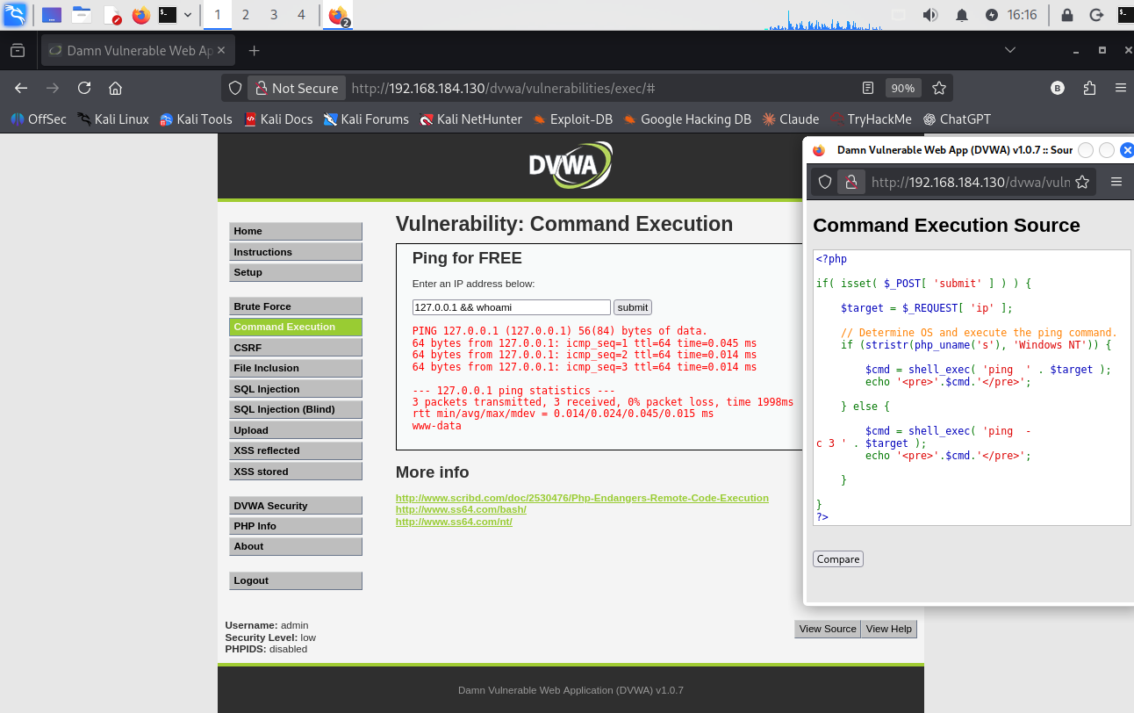
Figure 13: DVWA Command Injection demonstration showing the command output and vulnerable PHP source code.
The screenshot shows the input, successful ping output, www-data result, and the PHP source code.

Root Cause and Mitigation
The vulnerability occurs because the application directly combines user input with an operating-system command using shell_exec(). The && operator allowed the additional whoami command to execute.
To prevent OS Command Injection:
- Avoid executing operating-system commands when a safe built-in function is available.
- Validate input using an allowlist of permitted values.
- Pass command arguments separately without invoking a shell.
- Run the application with minimum required privileges.

Conclusion
OS Command Injection was successfully demonstrated in DVWA. The normal input executed a ping command, while the modified input also executed whoami, returning www-data. This shows that unsafe input handling can allow additional commands to run on the server. Proper input validation and safe command execution can help prevent this vulnerability.

Question 19
Explain Cross-Site Scripting (XSS) and its types: Reflected XSS, Stored XSS, and DOM-based XSS. Also explain how input validation and output encoding help prevent XSS.

Answer
Cross-Site Scripting (XSS) is a web vulnerability in which untrusted content is interpreted by a browser as executable script in a site's origin. This can let an attacker perform actions in a victim's browser or access data available to that page, depending on the application and browser controls. The three common types describe where the unsafe content comes from and how it reaches a browser execution context.
Type | How it happens | Brief example
Reflected XSS | A request value is immediately included in the response without safe context-specific encoding. | A search page displays a query string as HTML, so crafted input is interpreted by the browser instead of shown as text.
Stored XSS | Untrusted content is saved by the application and later displayed unsafely to one or more users. | A comment containing markup is stored and runs when another user opens the comment page.
DOM-based XSS | Client-side JavaScript reads untrusted data and sends it to a DOM sink that interprets it as HTML or script. | A page reads a URL fragment and assigns it to innerHTML, causing attacker-controlled markup to be parsed.

Prevention
Input validation checks that data matches the expected format, length, and allowed values for the field. It reduces unexpected input but cannot replace output encoding because valid text may still contain characters that have special meaning in HTML or JavaScript.
Output encoding converts data for the exact context where it is displayed so the browser treats it as text rather than code. Use framework-provided encoding for HTML, quoted attributes, JavaScript strings, and URLs as appropriate. For DOM updates, prefer safe text APIs such as textContent over HTML-parsing sinks. If users are allowed to author limited HTML, use a well-maintained sanitizer with a restrictive policy. Content Security Policy is an additional layer, not a substitute for safe encoding.
Reference: OWASP Cross Site Scripting Prevention Cheat Sheet. https://cheatsheetseries.owasp.org/cheatsheets/Cross_Site_Scripting_Prevention_Cheat_Sheet.html

Unit V – VAPT Reporting

